Ideation Phase
Empathize & Discover
Date
Team ID
Project Name | AI-powered Job Recruitment & Candidate Management System
Maximum Marks | 4 Marks

Empathy Map – Recruiter
1. Thinks & Feels
- Wants to hire the most suitable candidate quickly.
- Feels overwhelmed by many job applications.
- Needs an efficient system to evaluate candidates.
- Wants to reduce the recruitment time.
- Aims to improve the quality of hiring decisions.
2. Sees
- Hundreds of resumes from different job portals.
- Manual tracking using Excel sheets and emails.
- Delays in interview scheduling and approvals.
- Candidate information scattered across multiple platforms.
- Difficulty in monitoring the recruitment pipeline.
3. Says & Does
- "I need to shortlist candidates faster."
- Reviews resumes and candidate profiles daily.
- Coordinates with hiring managers.
- Schedules interviews and sends notifications.
- Tracks candidate progress throughout the hiring process.
4. Pains
- Time-consuming manual screening process.
- Difficulty in managing many applicants.
- Lack of centralized candidate information.
- Delayed approvals and communication.
- Risk of losing qualified candidates due to slow hiring.
5. Goals
- Hire the right candidate quickly.
- Automate repetitive recruitment tasks.
- Maintain a centralized recruitment database.
- Improve hiring accuracy using AI recommendations.
- Reduce overall recruitment cost and time.

Empathy Map – Job Applicant (Candidate)
1. Thinks & Feels
- Wants a fair and transparent recruitment process.
- Feels anxious while waiting for interview updates.
- Wants recruiters to recognize their skills.
- Expects timely communication.
- Hopes for a positive hiring experience.
2. Sees
- Job openings on multiple recruitment websites.
- Lengthy and repetitive application forms.
- Delayed responses from companies.
- Lack of visibility into application status.
- Confusing recruitment procedures.
3. Says & Does
- Searches for jobs matching their skills.
- Uploads resume and submits applications.
- Checks email regularly for interview updates.
- Attends interviews and follows up with recruiters.
- Updates profile information when required.
4. Pains
- No response after submitting applications.
- Long waiting time between recruitment stages.
- Unclear application status.
- Poor communication from recruiters.
- Uncertainty about the next steps.
5. Goals
- Receive timely updates about application status.
- Understand each stage of the recruitment process.
- Showcase skills effectively.
- Get selected based on merit.
- Experience a smooth and transparent hiring process.

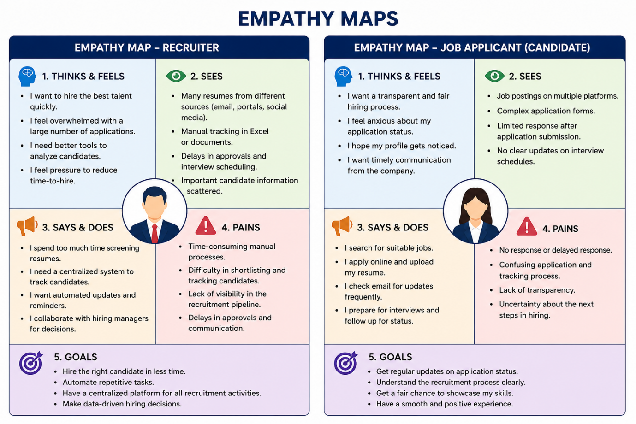

Key Insights
- Recruiters require an AI-powered platform to automate resume screening, candidate tracking, interview scheduling, and hiring approvals.
- Candidates expect transparent communication, real-time application tracking, and timely interview notifications.
- A centralized Salesforce-based recruitment system can improve collaboration, reduce manual effort, and enhance the hiring experience.
- AI-assisted recommendations help recruiters make faster and more accurate hiring decisions.
- The system benefits both recruiters and candidates by making the recruitment process efficient, transparent, and user-friendly.

